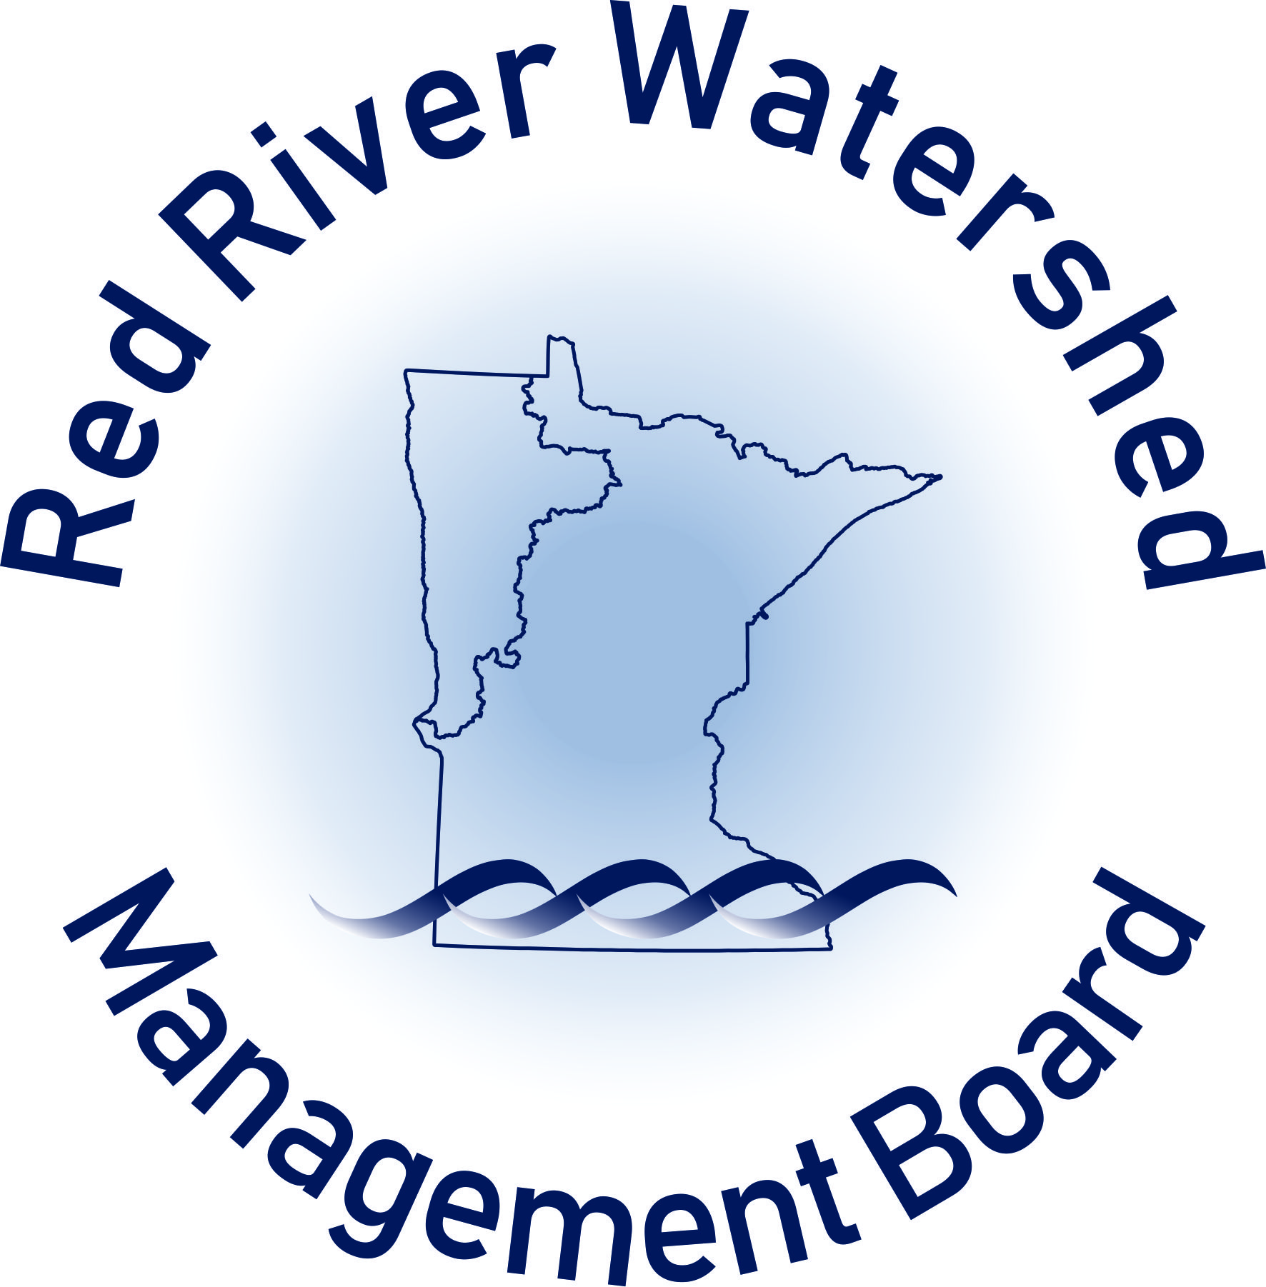

RRWMB APPLICATION REVIEW CHECKLIST
WATER QUALITY PROGRAM – COMPETITIVE FUNDS

CHECKLIST USE: This checklist is intended to be used by RRWMB staff and the Water Quality and Monitoring Advisory Committee (WQMAC) to support their review of competitive applications for water quality funding under RRWMB’s Water Quality Program (WQP). This checklist is used as a general guide to assess whether proposed projects conform with criteria and requirements of the WQP. (See Sections 1.C, III.A, III.B and III.C of the application).

Project Name: Click or tap here to enter text.
Applicant Name: Click or tap here to enter text.
Date of WQMAC Review: Click or tap here to enter text.
Form Completed by (name): Click or tap here to enter text.

SECTION I. IMPAIRMENTS: The WQMAC will consider and review existing water quality impairments the proposed project will address.

- The project improves or maintains water quality in to one or more of the following:
☐ Red River main stem.
☐ Tributary, or tributaries of the Red River.
☐ Other local waterbodies (lakes, headwaters streams, or impoundments).
Comments, if applicable: Click or tap here to enter text.

- The project is a physical improvement to a waterway or its drainage area (on-the-ground project).
☐ Yes
☐ No
Comments, if applicable: Click or tap here to enter text.

- The project implements surface water quality restoration/protection actions or achieves goals that were recommended by a water management plan such as:
☐ TMDL (restoration of impairments).
☐ WRAPS (Restoration of impaired waters & protection of unimpaired waters).
☐ 1W1P (local water quality priorities).
☐ Other local water management plan (please list):Click or tap here to enter text..
☐ Addresses emerging issues or concerns not addressed by a water management plan (please list): Click or tap here to enter text.

- Type of water quality impairments or protection concerns addressed by the project:
☐ Total suspended solids.
☐ Total phosphorus (river or lake eutrophication).
☐ E. coli.
☐ Low dissolved oxygen.
☐ Fish index of biological integrity.
☐ Macroinvertebrate index of biological integrity.
☐ Chloride.
☐ Chlorpyrifos.
☐ Nitrogen
☐ Other:
Click or tap here to enter text.

- Have load reductions have been estimated at the project outlet or at a downstream location?
☐ Yes
☐ No

If yes, include load reduction estimates: Click or tap here to enter text.

Method of load reduction estimation (model or tool): Click or tap here to enter text.

- WQMAC has reviewed water quality impairments, load reductions, and related issues and has the following comments, concerns, or recommendations: Click or tap here to enter text.

SECTION II. BEST MANAGEMENT PRACTICES (BMPs): The WQMAC will discuss how Best Management Practices (BMPs) as included in the application materials for this Project will address water quality. The project will include the following BMPs:

- Structural BMPs (Please list what structural BMPs will be implemented): Click or tap here to enter text.

- Non-structural BMPs (Please list what non-structural BMPs will be implemented): Click or tap here to enter text.

The WQMAC has reviewed BMPs and has the following comments, concerns or recommendations: Click or tap here to enter text.

SECTION III. MAINTENANCE, OPERATION, AND MONITORING: The WQMAC will consider maintenance and operational issues as findings and recommendations are developed and finalized:

- The project will include an operation and maintenance plan:
☐ Yes
☐ No
Comments, if applicable: Click or tap here to enter text.

- The project includes maintenance agreements with project partners:
☐ Yes
☐ No
Comments, if applicable: Click or tap here to enter text.

- Monitoring: A plan has been developed to monitor water quality once the project is constructed or implemented
☐ Yes
☐ No
Comments, if applicable: Click or tap here to enter text.

- A Joint Powers Agreement or Other Legal Entity is Responsible for the Project
☐ Yes
☐ No
Comments, if applicable: Click or tap here to enter text.

SECTION IV. TECHNICAL REVIEW: The WQMAC will take into consideration and refer to technical and engineering reviews and recommendations if available. Have any of the following reviews or reports been completed for this project?
☐ Local Review (please list): Click or tap here to enter text.
☐ RRWMB Technical Advisory Committee Review
☐ State Review:
☐ DNR Engineering Review
☐ DNR Technical Review (i.e., Habitat Review by DNR Fisheries)
☐ BWSR Engineering Review
☐ Fluvial geomorphology report
☐ Stressor identification report
☐ Federal Review (please list): Click or tap here to enter text.
☐ Other Review: Click or tap here to enter text.

SECTION V. ADDITIONAL CONSIDERATIONS: The WQMAC will also take into consideration the following information. This list is not all inclusive and other information may be requested by the WQMAC.

- Areal or linear extent of benefits: To what extent will the project have downstream water quality benefits?

Length of affected stream reaches (miles): Click or tap here to enter text.

Area of affected water bodies (acres): Click or tap here to enter text.

- Does this project provide benefits in addition to water quality improvements?
☐ Yes, the following additional benefits will occur:
☐ Aquatic habitat improvement.
☐ Riparian corridor or upland habitat/vegetation enhancement.
☐ Flood damage reduction.
☐ Other benefits: Click or tap here to enter text.

- Will the project cause, increase, or exacerbate flooding problems?
☐ Yes, the project will have the following negative effects.
☐ Increased peak discharge.
☐ Increased volume.
☐ Other: Click or tap here to enter text.
☒ If flooding problems will occur, please indicate where:
☐ Red River Mainstem
☐ Local Tributaries (please name them)
☐ There is no evidence the project will impact flooding.
☐ There is evidence the project will improve or complement FDR goals. If so, please list how: Click or tap here to enter text.

- Basin Technical and Scientific Advisory Committee Recommendations:
Is the project consistent with BTSAC Technical Paper #3?
☐ Yes
☐ No If no, provide reason: Click or tap here to enter text.

- Are there technical questions about drainage/flooding impacts and is further review warranted by the RRWMB Technical Advisory Committee?
☐ Yes
☐ No
Comments, if applicable: Click or tap here to enter text.

- Duration: Does the project work towards meeting long-term water quality outcomes?
☐ Yes
☐ No
Project life-span, if known: Click or tap here to enter text.
Comments, if applicable: Click or tap here to enter text.

- Other: Click or tap here to enter text.

SECTION VI. FUNDING:
- Application includes a summary of the project budget, funding sources, and partners.
☐ Yes
☐ No

- Leverage of Funds: Does the RRWMB funding have a positive effect on the amount or availability (eligibility considerations) of other funding or resources that can be leveraged?
☐ Yes
☐ No
Comments, if applicable: Click or tap here to enter text.

- The funding sources are properly apportioned in the project budget:
- Minimum of 50% from state, federal, or other sources.
- RRWMB funding – maximum of 2/3 of 50% (i.e. max of 33.33%) of the project budget.
- Local match – minimum of 1/3 of 50% (i.e. at least 16.67%) of the project budget.

Actual dollar amounts and percentages:
- Local, including applicant: Click or tap here to enter text.
- Requested RRWMB funds: Click or tap here to enter text.
- State, federal or other sources: Click or tap here to enter text.

- Anticipated timeframe for completion of the RRWMB-funded project or project phase:
☐ One year.
☐ Two to three years.
☐ More than three years.

- Cost Information Considerations:

SECTION VII. WQMAC FINDINGS AND RECOMMENDATIONS:

☐ The WQMAC finds that the project as proposed IS in conformance with the RRWMB Water Quality Program criteria and requirements

☐ The WQMAC finds that the project as proposed IS NOT in conformance with the RRWMB Water Quality Program criteria and requirements. (List why the project is not in conformance. Does the WQMAC have recommendations to address any deficiencies?) Click or tap here to enter text.

The WQMAC offers the following additional findings and/or recommendations for consideration by the RRWMB Managers:
- Click or tap here to enter text.
- Click or tap here to enter text.
- Click or tap here to enter text.
- Click or tap here to enter text.
- Click or tap here to enter text.

